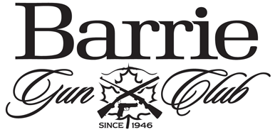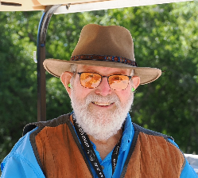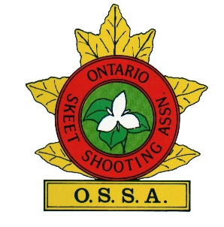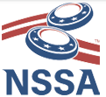
The Barrie Gun Club is proud to present the
“Doug Bailey Memorial” 2x100 12ga
A NSSA-OSSA Registered 2x100
12ga Skeet Tournament
Friday, May 8th, Saturday, May 9th, & Sunday, May 10th 2026
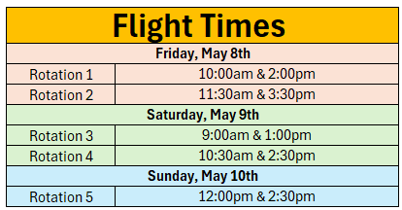
The event will feature full orange Lawry brand targets.
Ties to be determined by long run (front to back, and back to front if needed).
Saturday and Sunday the kitchen will be open for breakfast and lunch. Friday there will be a BBQ at the fields
Entry Fee: $120, Juniors $70 (juniors not eligible for Class purse) e-transfer, cash or cheque (including day fees)
HOA $200.00 (will be eliminated from Class purse)
$10.00 per person will be returned to class for HOA, (individual 100s will be honours only)
Shoot management reserves the right to change the program if necessary.
To register please contact Jim Malcolm – jims98flhtci@gmail.com or 705-238-2531
Please ensure OSSA and NSSA fees are paid prior to the event.
ontarioskeet.ca / mynssa.nssa-nsca.org

